**F- ALERT : Fire Disaster Management Using**

**Machine Learning**

Purva Gharat+

purvagharat28@gmail.com

Kunal Das+

KunalGTN7100@gmail.com

Jincy Jacob+

jincysarajacob2597@gmail.com

Prof. Archana Shirke+

archanashirke25@gmail.com

Elvis D’Costa+

elvisdcosta44@gmail.com

Information Technology+

Fr. C. Rodrigues Institute of Technology

Vashi,Navi Mumbai,India

***Abstract* — It is estimated that more than USD 7 trillion worth of economic damage and 8 million deaths via natural disasters have occured since the start of the 20th century and have caused bad impact on the society, destroying lives and properties. Also the year 2018 continues to prove catastrophic for Mumbai when it comes to combating fire incidents. Introduction of technological advances into disaster management has proven to be of great value. Despite these advances, no one can tell with complete accuracy when a place will catch fire, or how powerful a hurricane will be on landfall. However, observation and data are powerful tools, so prediction is getting better and faster. This data analysis is achieved by using various technologies such as Data Mining and Big Data, using which we can check for certain vulnerabilities from the data collected and analyze the possible disaster that can occur due to these vulnerabilities and also list out the different steps to mitigate the disaster. The benefit of being prepared for calamities and disasters is the fact that, in a society it can save one’s life or health even after the disaster has stricken. Thus with preparedness, response and recovery techniques, disaster can be managed to a certain extent.**

***Keywords — Fire management,Prediction, Big data ,mitigation plan***

# I. INTRODUCTION

Disaster management essentially deals with the management of resources and information towards a disastrous event and is measured by how efficiently, effectively and seamlessly one coordinates the resources.

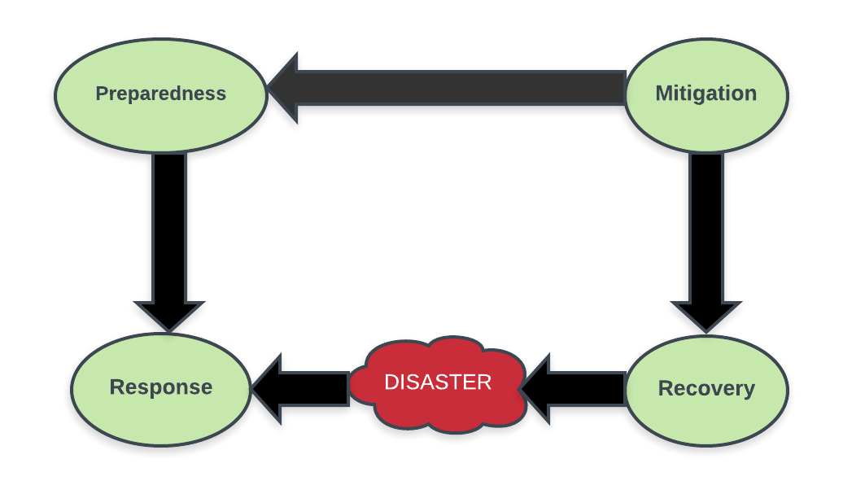Figure 1: Steps involved in any disaster management system

As shown in Figure 1, disaster management includes three basic phases: preparedness, response, and recovery. The efficient data collection, archiving and analytics is essential for effective disaster management, for which big data plays a very important part. Big data can be defined as the collection of large and complex data sets that are beyond the capacity of the conventional processing system . The preparedness phase is challenging for multi-hazard because it is hard to model all the consequences of a disaster due to the dependencies on many variables and uncertainties. This kind of dependency modeling requires big data with high accuracy for better modeling. It is possible to project the probable scenario of a catastrophe in big data era[2].

The previous year 2018 proved to be disastrous for Mumbai when it came to combating fire incidents. Ever since the tragic fire that broke out at Kamala Mills which killed 14 people in December 2017, the city has seen 12 major fire tragedies claiming about 22 lives, besides injuring many and destroying properties. A fire break out at a snack shop in Saki Naka area of the city in December 2017 caused the life of twelve people. On January 4, four people died after a fire broke out in Maimoon Building that housed residential complexes in the suburban part of Marol in Mumbai. Cine Vista, a film studio in KanjurMarg (West) was gutted in a massive fire on January 6. A fire was reported in the Mumbai’s Sessions Court building on the morning of January 8. Two firemen were injured in a massive fire that broke out on January 22 in an industrial area in Mumbai's Andheri. A fire broke out at a four-storey Army building in south Mumbai's Colaba area on March 17 and many more fire incidents have taken place in the year 2018 in Mumbai itself. Hence a fire disaster management system seems to be the need of the hour.

House fire is one of the major concerns for designers, builders, and residents of property.

**Some of the causes of household fire break-outs are:**

* Cooking Equipment: The damages or scratches on the gas cylinders can lead to leakage of gas which can catch fire.
* Heater: Keep portable heaters at least one metre away from anything that could easily catch fire such as furniture, curtains, laundry, clothes

## Electrical Equipment:A switch that is overloaded with double adapter plugs can cause a fire from an overuse of electricity. A extension cord for switch can also be a fire hazard if not used appropriately.

* Faulty Wiring: Homes and buildings with inadequate wiring can cause fires from electrical hazards.
* Flammable liquids: should be careful while handling flammable liquids like petrol, kerosene kept in the houses or garages.

# II. RELATED WORK

Various disaster management information systems are using different technologies to be a meaningful in typical disaster management.This section presents a light on different technologies discussed below :

Jovilyn Therese B. Fajardo have described a disaster management system Android application known as MyDisasterDroid that determines the optimum route along different geographical locations that the volunteers and rescuers need to take in order to serve the most number of people and provide maximum coverage of the area in the shortest possible time.[9]

Mr.T.Rajasekaran has described a Forest fire prediction and alert system using big data,this method involves collecting and analyzing the data collected from the wireless sensors embedded in the forest corresponding data is aggregated then methods are applied to predict the forest fire.They have used a machine learning tool called Mahout for clustering and filtering the datasets and predict the output.GSM technology is used for providing the alert message to the people so that proper relocation occurs to a safe place.Signal and Infrared image processing is used to monitor the signals and images of the entire forest for every 30 min and those data will be stored in datasets, by using those data we can be able to predict the forest fire in advance.[11]

Mohammad Sultan Mahmud, Md. Shohidul Islam and Md. Ashiqur Rahman suggested a solution for individual sensors that were used for detecting fire but could not detect the level of fire and notify the emergency response units. They have proposed an intelligent early fire detection system that would not only detect the fire by using integrated sensors but also notify the appropriate authorities including fire department, ambulance services, and local police station. Signals from the embedded detectors e.g., heat, smoke, and flame go through the machine learning algorithms to check the potentiality of the fire as well as broadcast the predicted result to various parties using a GSM modem. The output of this development minimized false alarms, thus making this system more reliable.[10]

Md. Shahinoor Rahman described the role of big data in disaster management, big data from these various sources is getting attention from disaster managers and researchers. Management and analytics of big data can be effective in all phases of disaster management. Even though there are challenges using these big data in an emergency, but big data already proves its effectiveness. As the big data application in disaster management is going to affect many improvements in the capacity level, management level, and research level which will help to get the maximum benefits from this modern opportunity[8].

# III. PROPOSED SYSTEM

The proposed system is a cloud based fire detection that collects, organizes, manages several fire hazard databases and helps in the detection of fire hazards.

A. Modules

The system will be available to the users in the form of a web application.

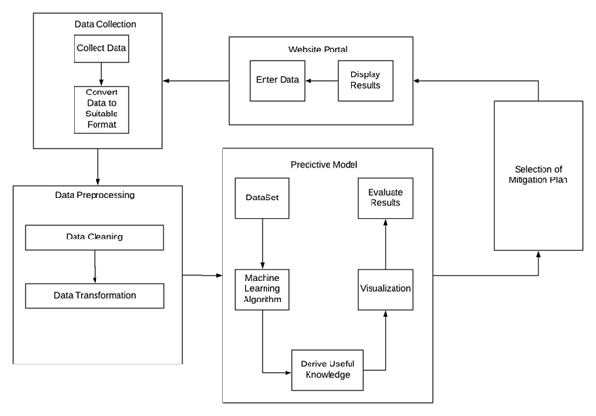

Figure 2: System Architecture Block Diagram

The above figure 2 explains the block level representation of the project. It shows how different modules will be interacting with each other and also the entire flow of the system.

The system consists of the 5 Modules as shown in the Figure 2

1. **Data Collection Module** :In this phase we collect relevant data from different sources.Data are collected from various sources for analysis and event detection. Data sources considered for obtaining fire related data are the fire stations. Collected data are in different formats such as handwritten, sensor data, websites, etc. The corresponding data is aggregated to a csv file.

2. **Data Preprocessing Module** : The data acquired through the data collection process is processed to convert it into a format which is favorable for the Machine Learning Process. In this module data cleaning and data transformation is performed.

3. **Machine Learning/ Predictive Model Module** : This module uses a machine learning algorithm to implement a

Predictive model.The typical workflow for machine learning module consists of many phases:

* Identifying a fire related problem to solve and a metric for measuring results.
* Finding, cleaning, and preparing appropriate data.
* Identifying the best attributes for the collected data for prediction of fire
* Building, evaluating, and tuning models.
* Using models to generate predictions, and provide mitigation steps.

4. **Selection of Mitigation Plan Module** : Based on the results obtained from the Predictive model, this module will decide as to what mitigation plan will be the most suitable one for the given situation.

5. **Website Portal Module** : The final results of our project will be displayed on a website Portal.This application consists of a login module for the fire officer who wants to use it to enter new fire incidents.Mitigation plan for the particular disaster will also be displayed on website for the users.

## B.Algorithm

The different types of algorithms that we are going to use in our system are as follows :

1. Multivariate regression [7]

Multivariate regression will be utilized in our system as it belongs to the class of Supervised learning.

There are various problems addressed by this regression like if the data is collected and some of the variables are defined the relationship between them can be determined. :

a ) Selecting the features: Finding the features on which a response variable depends (or not) is one of the most important steps in Multivariate Regression. To make our analysis we have selected the features to be the call time which denotes the time when there is a fire-breakout and the extinguish time when the fire was extinguished.

b ) Normalizing the features: The call time is then scaled in the range of (0,24) to represent in the 24 hour format in order to make better analysis.

c ) Identifying Hypothesis and Cost function and Minimizing the Cost function

d ) Testing the hypothesis: So this algorithm will be used in analyzing the big data, getting best possible outcome for the input and for forecasting and finding out cause and effect relationship between variables and will help to detect outliers.

2. Clustering

Clustering is performed to group a set of objects in such a way that objects in the same group are more similar to each other than to those in other groups. K-means algorithm will be used for clustering in our system. It is used for clustering of call time (Time of the reporting of any fire that has occurred). This is used to find out which time of the day is most prone to fire accidents as derived from the past incidents.

DBScan is another clustering algorithm that is used for visual purposes. It is used to plot regions or zones in the map based on the severity of fire hazards that have taken place in that area. Severity is shown on the map with the help of the colour of the zones that are plotted using the clustering algorithm.

## C. Working

* Identifying vulnerabilities from collected data

After collecting fire related data, regression and clustering are performed on the data and the severity score of the fire is calculated based on the four parameters- casualty, second call to the fire station, extinguish time and who extinguished fire(firemen or civilians).

* Display on website

The system will be made accessible to the firemen and civilians through the website. The firemen of a particular area will have their login account in the website, through which they can enter the new incidents occurring in that area. The users can know the vulnerabilities of their area through the various patterns displayed in the site.

* Prediction of fire

It is necessary for us to detect the fire as early as possible and it would be better if it is predicted in advance.The system will help them to identify the probability of fire at a particular time in the day and also its severity. The site will also display a map indicating the highly and moderately fire- prone areas through blue and green zones respectively.

## D. Applications

It predicts the occurrence of a fire break-out in a region based on the vulnerabilities found after the analysis of the collected data.It helps the people to identify a region that is likely to catch fire.It also provides the people with proper mitigation plan to avoid the fire.

# IV. RESULTS

For the dataset the real-time data from fire-station is collected.

The data is classified based on the attributes of the dataset

The dataset includes the following attributes: “Location” of the fire incident ,the “Cause of fire”, the “Type of environment” where the fire has occurred (road , residential ,office ) , “Number of firemen” sent to extinguish the fire “Number of vehicles” required , “Call time” represents at what time the fire occurred, the “Return time” helps to identify the time required to extinguish the fire, “Second call” depicts the fire was severe and more vehicles were needed to extinguish it ,any “Casualties occurred”, and the “Action taken” by civilians or firemen.

This dataset will be updated by the firemen by entering details through a webform, while encountering with new fire incidents.

The website consists of an admin webpage that takes the input from firemen on the incidents noted by them on a daily basis and this will be directed to the csv file.This data can be used for further analysis to get more accurate results. The website also has a contact us page where residents can input there address to check specifically if that region or area is safe from fire or not.

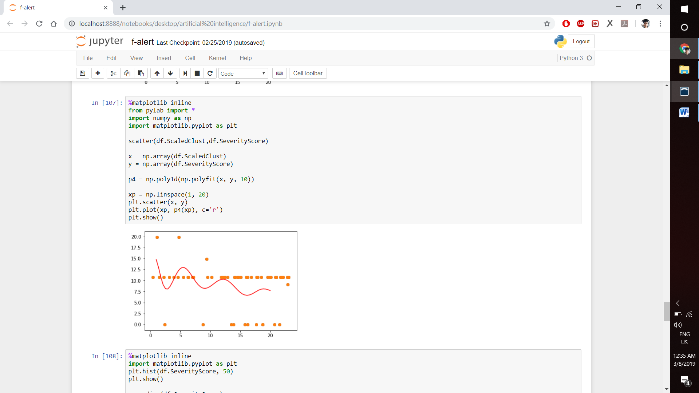

Figure 3: Multivariate regression graph

The figure 3 represents a graph for the multivariate regression which shows the relationship between distribution of severity score (x-axis) and the time of occurrence in a day(y-axis). The graph helps to predict that throughout the day at what time the fire incident occurred was more severe.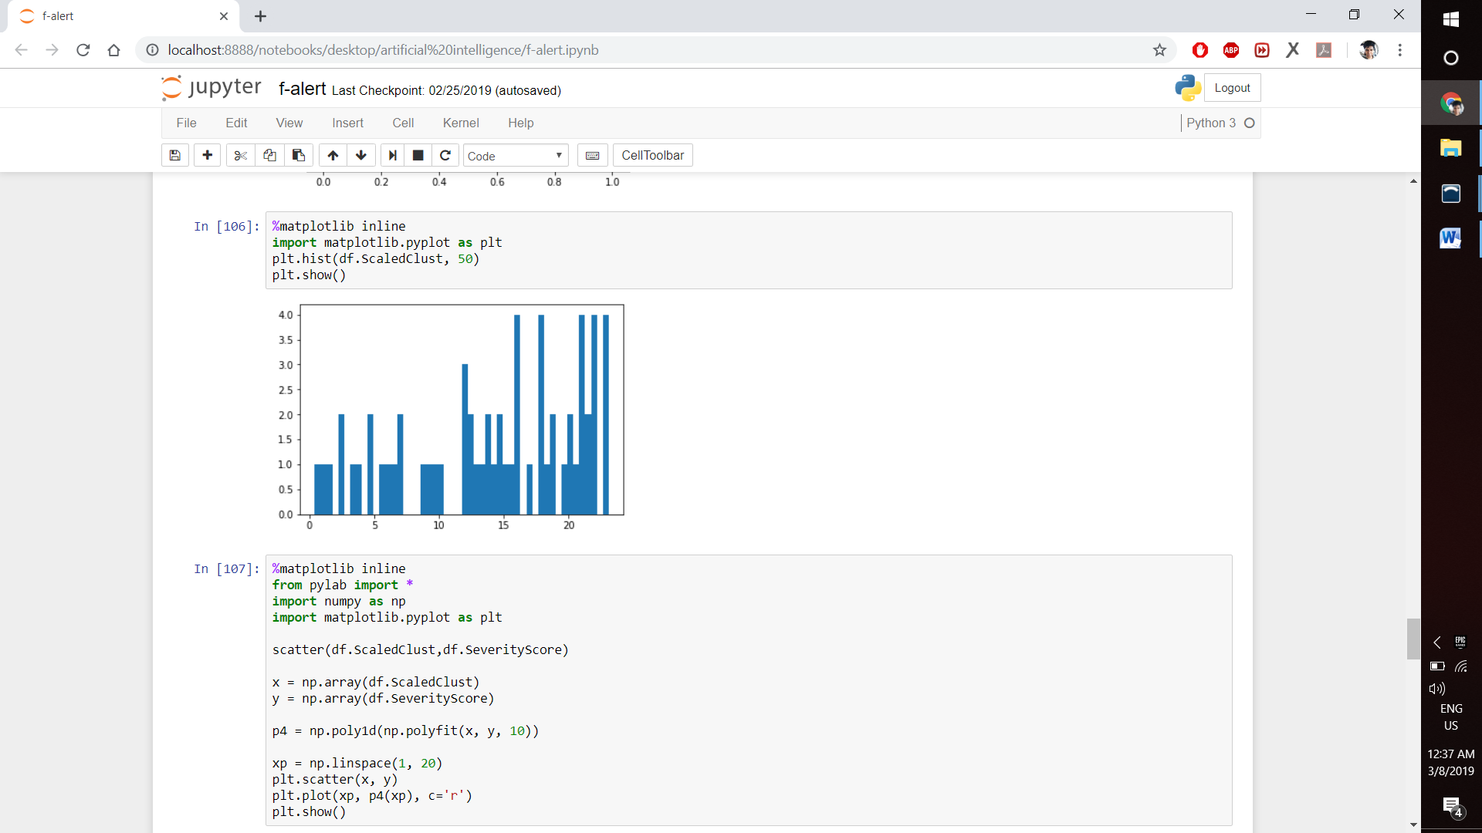

Figure 4: Histogram

The above figure 4 represents a histogram which tells the frequency of fire occurrences at different times of the day.

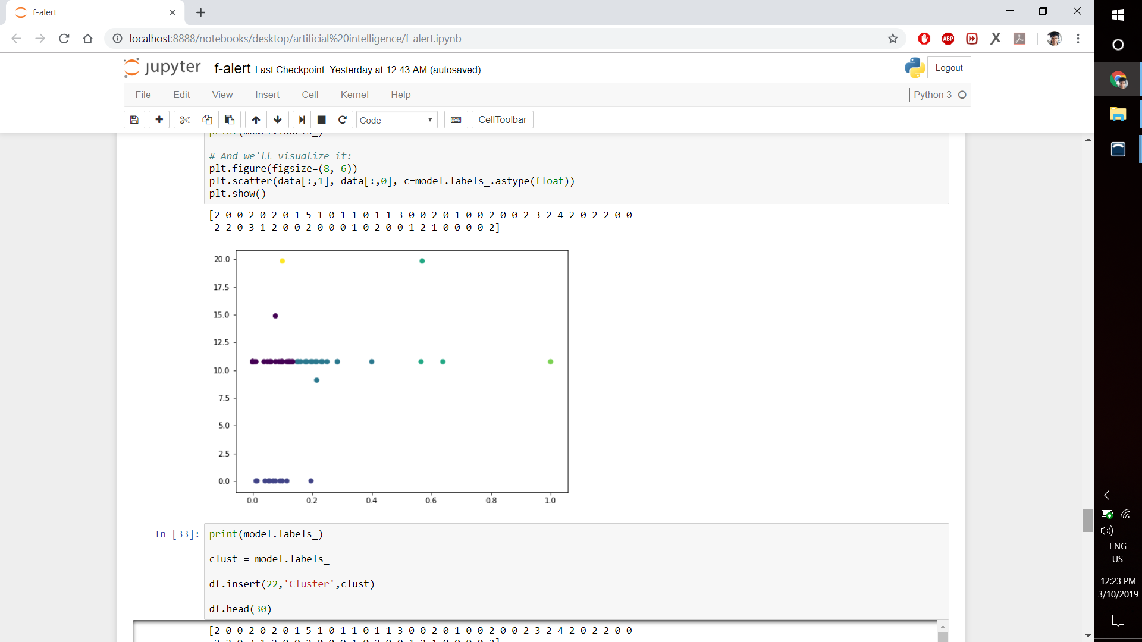

Figure 5: K-means Clustering

The above figure 5 represents clustering is done by using parameters as extinguish time of fire with respective the severity score of it ,it tells the time at which most of the incidents occurs.

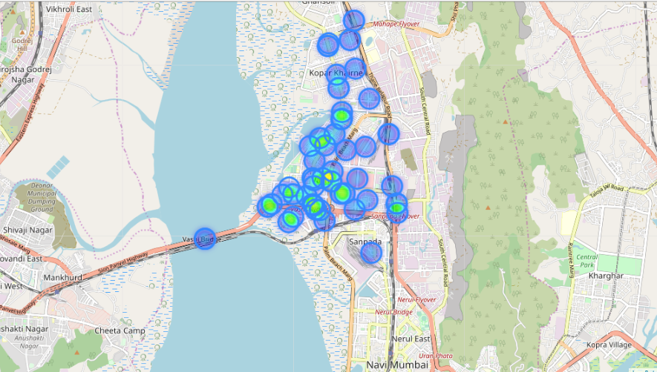

Figure 6: Map showing fire prone areas.

The above figure 6 represents a map of Vashi it shows all the fire incidents that were happened in 2018 and the blue spots shows the less severe regions and the green spots depicts the more severe regions in that area.

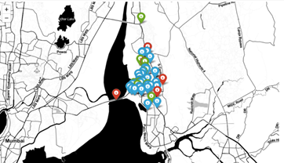

Figure 7: Map showing areas prone to different levels of severity of fire.

The figure 7 represents a map of Vashi, it shows all the fire incidents that were happened in 2018 and the red markers indicate highly severe fire zones, blue markers indicate moderately severe fire zones and green markers indicate low severe fire zones.

# V. CONCLUSION

The objective of this paper is to aware the civilians about the various household fires that can take place in their areas and also provides mitigation plan. Big data from the fire stations are taken and these data help the policy makers and first responders to come up with quick and concrete decision on the number of people affected, type and nature of the damage and where to allocate the resource. Crowdsourcing and cloud computing approach can be used to get required information for emergency management by analyzing big data. Machine learning approach and parallel processing approach saves the valuable processing time during an emergency. With the help of big data the disaster management can be done more efficiently at organization level. Hence, any person of a particular area can easily use the application to get mitigation plans and know the vulnerabilities for a particular disaster, primarily fire hazards.

Future studies will focus on expanding the applicability of this system to not only predicting fire disasters, but also various other disasters through Web or mobile application services, and perform preventive actions for optimal disaster recovery.

# VI. REFERENCES

[1] Author: Satish Modh, Edition First, VES Institute of Management, Studies and Research, Mumbai, Publisher: Macmillan Publishers India, dated January 2010

[2] Md. Shahinoor Rahman, Liping Di , Md. Esraz-Ul-Zannat : The Role of Big Data in Disaster Management ,September 23 - 24, 2017

[3]Marion,Unsplash,Online:https://www.eartheclipse.com/natural-disaster/causes-and-effects-of-drought.html,Accessed on 27 September 2018

[4] The International Federation of Red Cross and Red Crescent Societies (IFRC)

Online:http://www.ifrc.org/en/what-we-do/disaster-management/about-disaster-management/ Accessed on 18 September 2018

[5]RohtithGandhi,Online:https://towardsdatascience.com/introduction-to-machine-learning-algorithms-linear-regression-14c4e325882a, Published :18 April, 2016

[6] Neeraj Kumar; Alka Agrawal; R. A. Khan : Emergency Information System Architecture for Disaster Management: Metro City Perspective, May-June 2017

[7]Geeks for geeks,

Online:https://www.geeksforgeeks.org/multivariate-regression/Published :28 September 2018

[8] Muhammad Arslan, Ana Roxin, Christophe Cruz, Dominique Ginhac. A Review on Applications of Big Data for Disaster Management. The 13th International Conference on Signal Image Technology Internet, Dec 2017, Jaipur, India.

[9] Varsha S. Sonwane,A mobile disaster management system on mobile phones using Google maps,International Journal of Computer Science and Information Technologies, Vol. 5 (5) , 2014

[10] Mohammad Sultan Mahmud, Md. Shohidul Islam and Md. Ashiqur Rahman :Smart Fire Detection System with Early Notifications Using Machine Learning, Vol.16 (2) 2017.

[11] Mr.T.Rajasekaran, J.Sruthi, S.Revathi , N.Raveena :Forest Fire Prediction and Alert System using big data technology, Accepted: 31 July 2015.